Photos for CNC control retrofit evaluation
Page1
Machines in Motion, Inc.
Full View of your machine from each side and the back side if accessible. | How is the current control console mounted
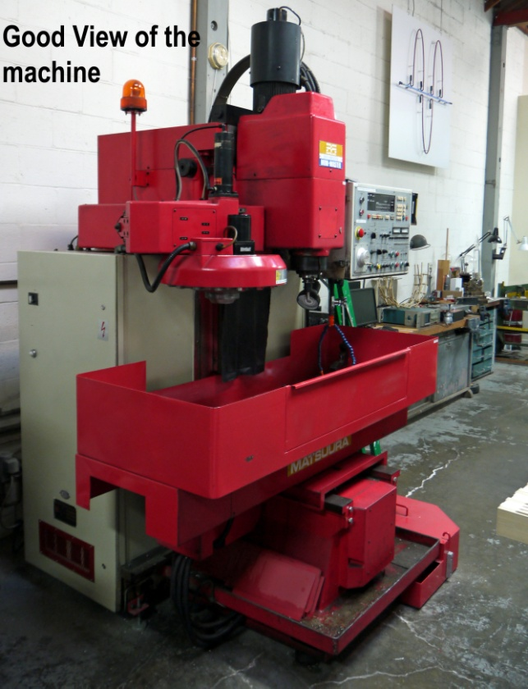 | 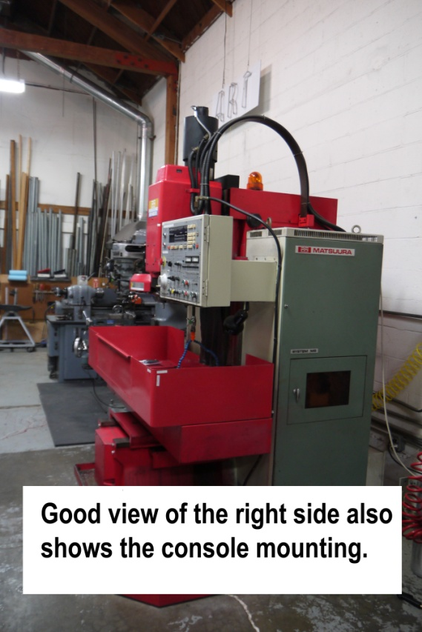  Built into a mounted enclosure?  Rolling floor stand or mounted inside a cabinet enclosure?  Machine mounted OEM swivel arm?  Frequently we can make use of the existing OEM console mounting.
This is too close | Photo of console needs a second view to reference size and location
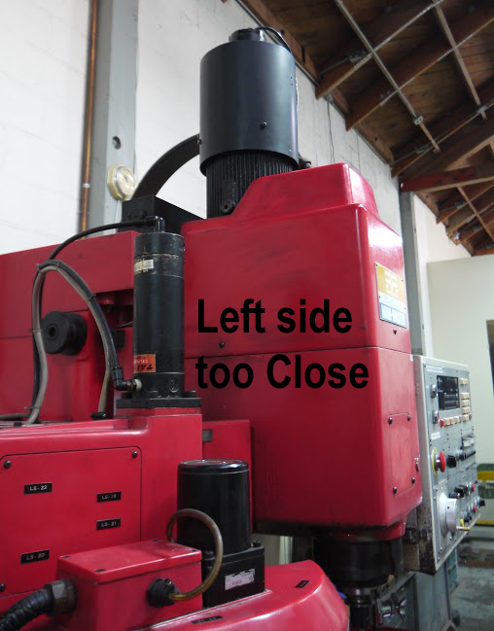 | 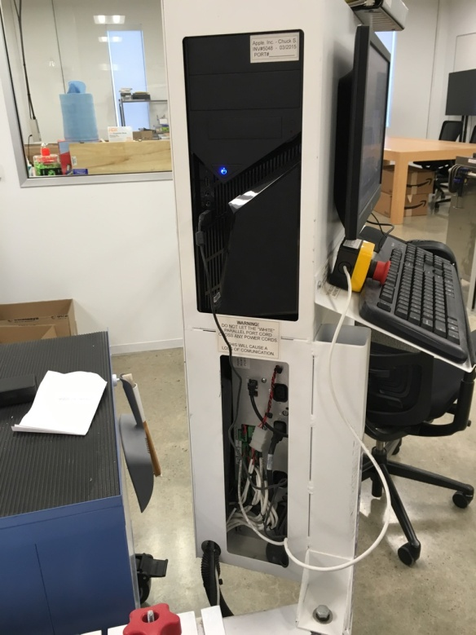

Photos for CNC control retrofit evaluation
Page2
Machines in Motion, Inc.
The label on each servo motors. This can be close up.  If unable to photograph list the text from each label. | View of how the servo motor is mounted – showing what might get in the way .
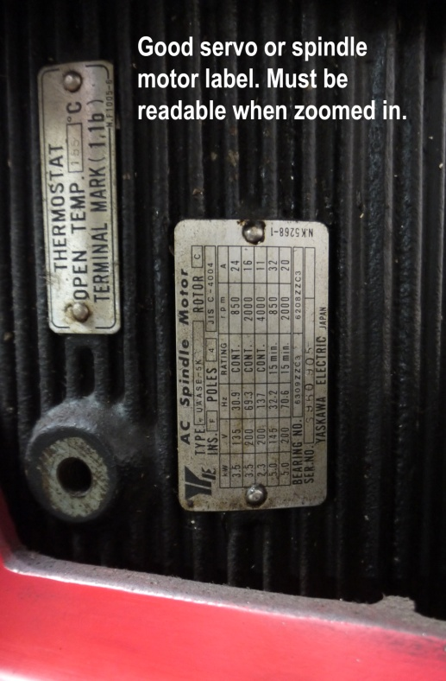 | 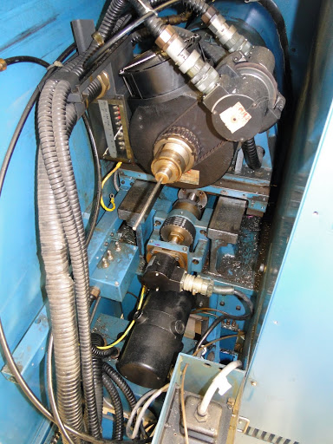  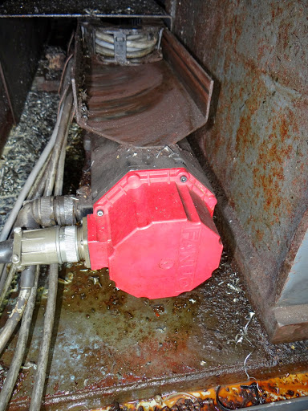
Full photo of the current electrical enclosure. | . . If space is limited you may need to photograph one half then the other half.
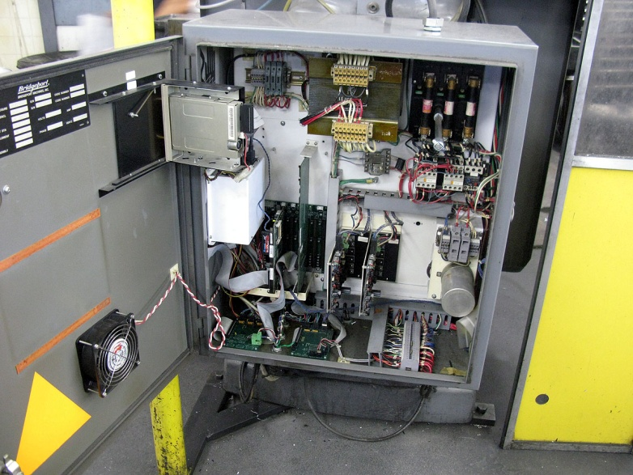  A good photo includes the sides of the enclosure. | 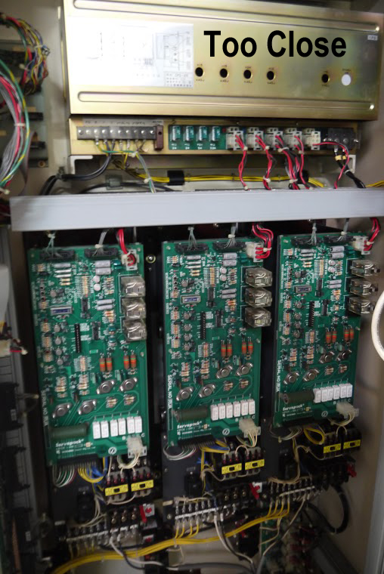

Photos for CNC control retrofit evaluation
Page3
Machines in Motion, Inc.
A photo of the autolube pump, tool changer, hydraulic | pump, or other devices that will need to be controlled.
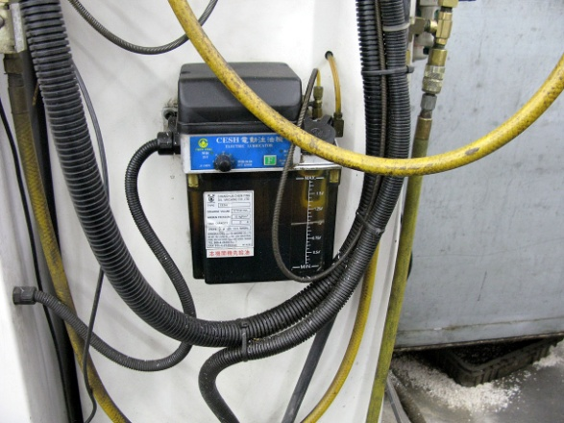  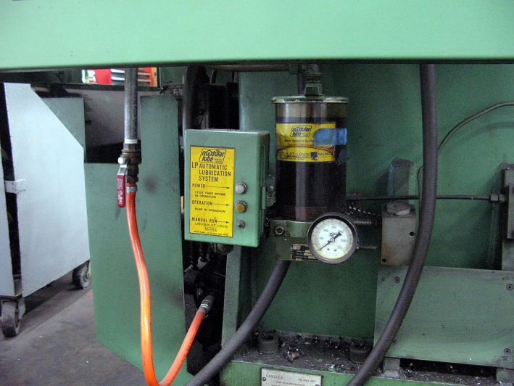 | 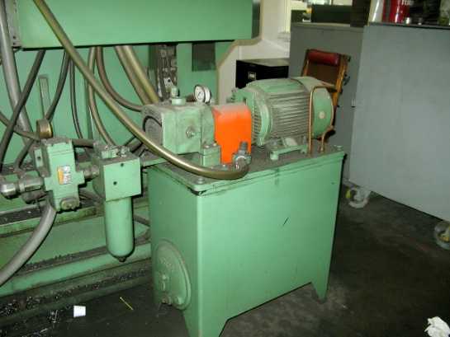  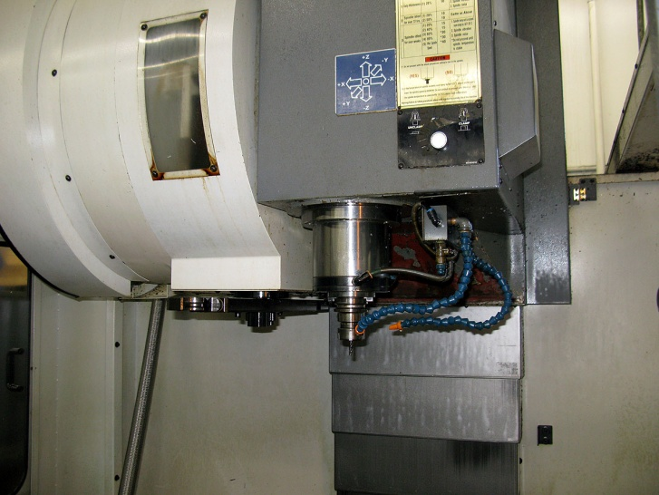

Some shops are darker than others. Be sure to hold your camera (phone) steady in low light conditions.
Most Email accounts can handle 5 to 10 meg in each email. Divide your photos in to multiple emails if needed.
Cell phone cameras seem to work well enough but do email your images.

Email to us at: centroid.controls@gmail.com

Once we receive your photos with a completed RFQ form we can begin generating a budgetary quotation for you.
Be sure to include a contact name and phone number in case we have additional questions.

Thank you for selecting Machines in Motion, Inc.

Machines in Motion Inc.
(714) 528-7061
http://machinesinmotion.com

